November 15, 2024

Developing HR Leaders of Tomorrow through Professional Development and Research

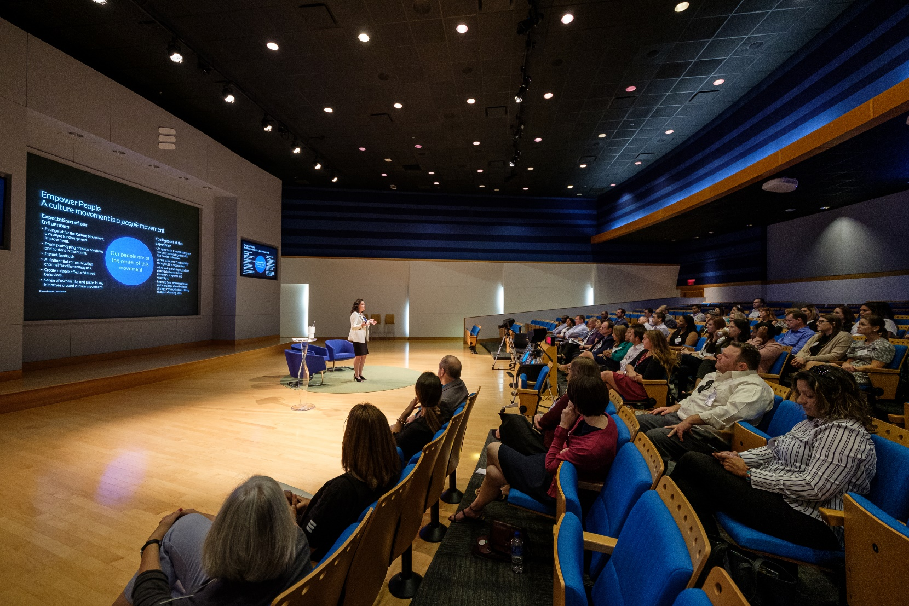

*The People Center in the G. Brint Ryan College of Business is the hub for all Human Resource related academic pursuits within UNT, providing resources and pathways to improve student experience, outreach impact with corporate partnerships, and research productivity.*

*In this Research Brief, we share the latest publications from People Center Researchers and insights for practice.*

**[](https://www.linkedin.com/company/the-people-center-at-unt/) The People Center**

**The G. Brint Ryan College of Business Follow us on LinkedIn!**

**University of North Texas**

**What We Do While Waiting: The Experience of Vulnerability in Trusting Relationships**

**Authors - Gary A. Ballinger, F. David Schoorman, and Kinshuk Sharma\***

When and why do people engage in dysfunctional behaviors in the time between a decision to take a risk based on trust and the finding out whether that trust is validated or betrayed? The authors propose that the vulnerability experienced as individuals who place their trust in others wait for the others’ responses can trigger behaviors that can jeopardize those relationships and the possibility of quality future interactions. However, factors such as new information learned about the other person and the strength of the relationship affect the trustor’s emotional experience and likelihood of engaging in dysfunctional behaviors….[**READ MORE**](https://journals.aom.org/doi/epub/10.5465/amr.2022.0080)**.**

**The Multiple Roles of Network Ties in the Employee Job Search Process**

**Authors - Caitlin M. Porter, Julie Hancock*, David G. Allen, and Galen P. Snyder**

Categorizing employee social network ties into strong and weak internal and external ties, Julie Hancock and her colleagues found that strong ties, such as close friends or family, offer emotional support and reliable job leads, while weak ties, like acquaintances, provide access to diverse and novel information. Overall, this study highlights how different types of social relationships at work can significantly impact the success and speed of a job search and that strong internal ties have dual, opposing influences on job search behaviors. The study also offers suggestions for how organizations might facilitate relationships at work through various programs to encourage both external and internal relationships….[**READ MORE**](https://onlinelibrary.wiley.com/doi/10.1002/hrm.22135)**.**

**Passion Versus Positivity: How Work Passion and Dispositional Affect Predict Job Satisfaction and Its Facets**

**Author - Karen Landay*, Shoshana Schwartz, Jaime L. Williams**

In this study of 327 employees across a variety of occupations and industries, Karen Landay and her coauthors identified harmonious work passion – a controllable passion for work that is developed voluntarily – as a key predictor of satisfaction with every aspect of jobs (e.g., pay, supervision, coworkers, etc.). Furthermore, they found that harmonious work passion was a better predictor of job satisfaction than an overall tendency toward positive emotions, highlighting the essential difference between employees who are passionate rather than merely generally happy. Taken together, their research demonstrates the potential utility of offering self-assessments of work passion to all employees and the benefits of recruiting harmoniously passionate individuals, as they will be more likely to be satisfied with all aspects of their jobs….[**READ MORE**](https://onlinelibrary.wiley.com/doi/abs/10.1002/hrm.22239)**.**

