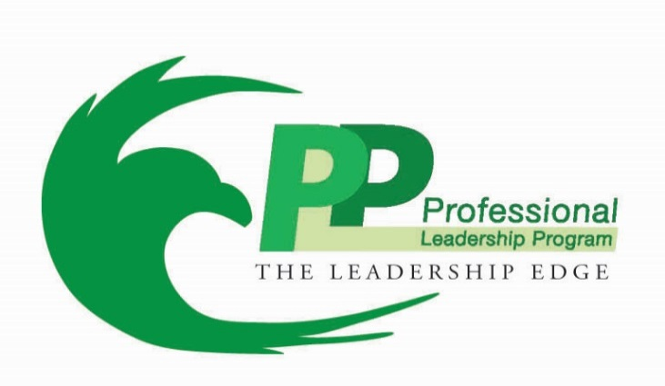

University of North Texas
PLP Executive Mentor Handbook

Dear Mentees & Mentors:

You are about to undertake a journey to enhance your professional and personal development that will not only impact your life, but, the lives of those around you.

Mentoring is a powerful and essential part of life, and it can be the leverage that propels you to do great things for many years to come. Our model of mentoring is grounded in servant leadership, and both you and your mentor will be provided with the tools, information, and support needed to develop and refine these attributes.

You’ve often heard the phrase, “you get out what you put in” and PLP is no different. The PLP mentoring experience will help you develop a leadership style that is sustainable for the future. Mentoring requires communication, vulnerability, willingness and accountability – four qualities that seem to be hard for humans to reveal. However, if you don’t embrace these four qualities, your PLP mentoring experience will not flourish, nor be successful. Don’t be afraid, you’re both just people trying to help each other and learn from each other.

So “lean in” and enjoy the experience of learning from some of the best knowledge experts and Fortune 500 professionals in the DFW marketplace, all while engaging with a diverse and talented group of peers.

Best Regards,

Billy E. Johnson
Executive Director
Mission and Vision of PLP
Mission: To prepare exceptional students for business leadership by supplementing degree competency with executive mentoring, corporate exposures, professional development, and key business skills and values.
Vision: To be a nationally recognized professional leadership program for the development of exceptional business leaders.
Objectives of Executive Mentoring Program
- Help the student develop his or her career vision.
- Create environment for professional development in business and social settings
- Provide resources that will aid the student in career decisions
- Increase individual strengths through positive coaching and experiences
- Expand student thinking from campus to the corporate and global world

Mentor Requirements & Guidelines
- Mentor must have 7+ years professional experience, or recommendation by PLP staff or board
- Have a servant leader mentality
- Meet once every 4-6 week period, face-to-face.
- Shadow Days for Mentee—highly encouraged for those who are able and/or willing
- Encouraged to attend Fall and Spring Orientation and Business After Hours events
- Attend End of Year Recognition Banquet in April

Mentoring History & Facts

History of Mentoring
The term "mentoring" originates from Homer's Odyssey - the character Mentor coaches and counsels Telemachus, Odysseus' son as Telemachus prepares to take on the responsibilities of the family in his father's absence. Mentor also advises Odysseus on how to search for his father. Telemachus thanks him for his help: "Sir, I thank you for your kindness; you might be a father speaking to his own son, and I will not forget one word of what you say..."

The term mentoring has been used ever since to describe a relationship where an individual receives advice, coaching and/or counseling from a more senior wise counsel. For the mentor, it is an opportunity to develop an individual both personally and professionally; for the mentee, it is an opportunity to learn from a sager person. Typically, these relationships last several years and often end in colleagueship and/or friendships.

As more and more mentoring programs are implemented in organizations, mentoring is being defined in a broader, more fluid way, i.e., colleagues, peers and even subordinates can be mentors and these relationships may last only days to weeks to months, not always years. The goal of many of these programs is for each individual to have many mentors.

What is mentoring?
There are a number of different definitions for the word “mentoring.” Consider some of the following:
• “The process in which an experienced colleague is assigned to an inexperienced individual and assists in a training or general support role” (www.lmuaut.demon.co.uk/trc/edissues/ptgloss.htm)
• “Dealing with individuals in terms of their total personality in order to advise, counsel and/or guide them with regard to problems that may be resolved by legal, scientific, clinical, spiritual and/or other professional principles” (www.oalj.dol.gov/public/dot/refrnc/dotappb.htm)
• “A form of teaching that includes walking alongside the person you are teaching and inviting him or her to learn from your example” (www.imb.org/CPM/Glossary.htm)
• “A learning partnership between an experienced employee (mentor) and a less experienced employee (protégé) for the purpose of sharing knowledge and information. Mentoring provides all with the opportunity for and access to professional growth and development” (http://www.nist.gov/admin/diversity/handbook02.htm)
• “An active, creative process that demands energy and commitment invested in another person and their success” (1996 Vision Connections, Inc ©)

Benefits of a Mentoring Relationship
For the Mentors:
- Personal satisfaction from fostering the professional development of a student.
- Opportunities to strengthen knowledge base and improve communication skills as students expose mentor to new ideas and perspectives.
- Improvement of coaching, leadership, teaching and counseling skills.
- Sense of accomplishment by assisting an emerging professional to develop his/her potential.
- Personal growth.
- Demonstrates commitment to personal and professional development
Mentor/Mentee Ideas

- Find a leadership or business book to read and discuss together.

- Utilize PLP student scorecard to set goals and see progress

- Provide positive reinforcement and respectful criticisms.

- Discover your best form of communication (email, text, calls, etc.)

- Regularly check in on your goals, progress, and action plans for how to move forward.

- Attend a UNT event together (students often get in free with student ID)

- Meet for a casual meal or cup of coffee

- Let the mentee see the mentor as a person as opposed to a “businessman/woman” – invite mentees to non-business related functions when suitable

Important Contacts

Natalie Bernard
PLP Coordinator
Natalie.bernard@unt.edu

Rachel Cleveland
PLP Assistant Director
Rachel.cleveland@unt.edu

Billy Johnson
PLP Director
Billy.johnson@unt.edu

Ray White
PLP Advisory Board Chair
Ray.white@icuc.social

Professional Leadership Program Office
Business Leadership Building, Room 105
Mailing Address: 1155 Union Circle, #311160
Denton, TX 76203
940-565-3855
plp@unt.edu

